# **Name: Abdurrahman Qureshi**

# **Roll No: 210451**

Practical No: 11

**1) Write a program to count the number of clicks performed by the user in a Frame window**

**CODE:**

import javax.swing.*;  
import java.awt.*;  
import java.awt.event.ActionEvent;  
import java.awt.event.ActionListener;   
public class Main {  
 private int clickCount = 0;   
 public Main() {  
 JFrame frame = new JFrame("Click Counter"); frame.setDefaultCloseOperation(JFrame.*EXIT_ON_CLOSE*);  
 frame.setLayout(new BorderLayout());  
 JPanel buttonPanel = new JPanel();  
 JButton btn = new JButton("Click Me");  
 buttonPanel.setBackground(Color.*DARK_GRAY*);   
 JLabel countLabel = new JLabel("Click Count: " + clickCount);   
 btn.addActionListener(new ActionListener() {  
 @Override  
 public void actionPerformed(ActionEvent e) {  
 clickCount++;  
 countLabel.setText("Click Count: " + clickCount); }});  
 buttonPanel.add(btn);  
 frame.add(buttonPanel, BorderLayout.*CENTER*);  
 frame.add(countLabel, BorderLayout.*SOUTH*);   
 frame.setSize(300, 150);  
 frame.setVisible(true); }  
 public static void main(String[] args) {  
 new Main();}}

**OUTPUT:**

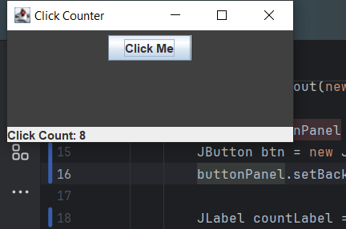

**2)** **Write a program to demonstrate the use of mouseDragged and mouseMoved method of MouseMotionListener**

**CODE:**

import javax.swing.*;  
import java.awt.*;  
import java.awt.event.MouseEvent;  
import java.awt.event.MouseMotionAdapter;  
  
public class Main {  
 public static void MouseMotionDemo() {  
 JFrame frame = new JFrame("My mouse movin hear n ther");  
 frame.setDefaultCloseOperation(JFrame.*EXIT_ON_CLOSE*);  
 frame.setLayout(new BorderLayout());  
  
 JLabel coordinatesLabel = new JLabel("Mouse Coordinates: (0, 0)");  
 coordinatesLabel.setHorizontalAlignment(JLabel.*CENTER*);  
  
 frame.add(coordinatesLabel, BorderLayout.*SOUTH*);  
  
 frame.addMouseMotionListener(new MouseMotionAdapter() {  
 @Override  
 public void mouseMoved(MouseEvent e) {  
 int x = e.getX();  
 int y = e.getY();  
 coordinatesLabel.setText("Mouse Coordinates: (" + x + ", " + y + ")");  
 }  
 });  
 frame.setBackground(Color.*DARK_GRAY*);  
 frame.setSize(400, 300);  
 frame.setVisible(true);  
 }  
  
 public static void main(String[] args) {  
 SwingUtilities.*invokeLater*(new Runnable() {  
 @Override  
 public void run() {  
 *MouseMotionDemo*();  
 }  
 });  
 }  
}

**OUTPUT:**

